NOT GATE



OR GATE



XOR GATE



AND GATE



COMPARATOR

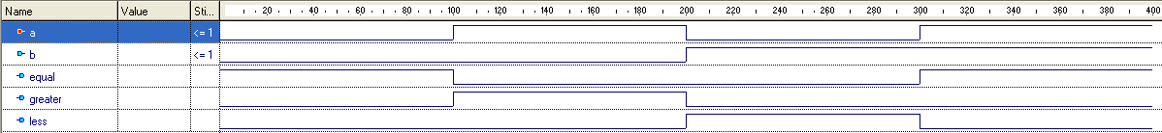

DECODER



DEMULTIPLEXER

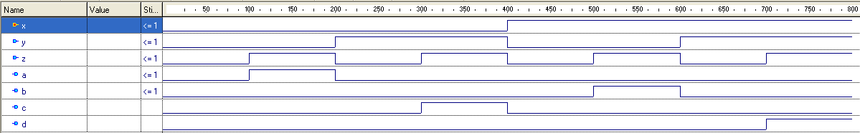

ENCODER



D-FLIP FLOP

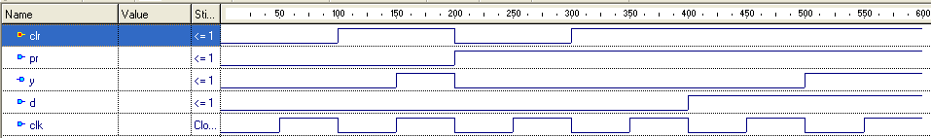

FULL ADDER

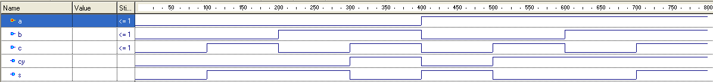

HALF ADDER



MULTIPLEXER

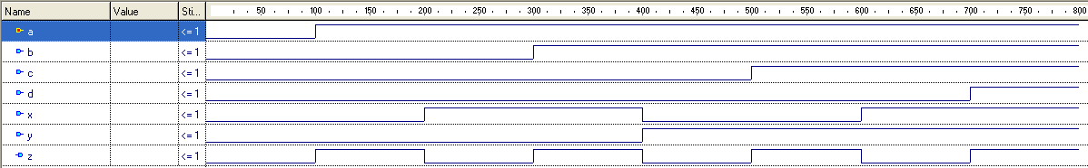

NAND GATE



NOR GATE



CODE CONVERTER



COUNTER

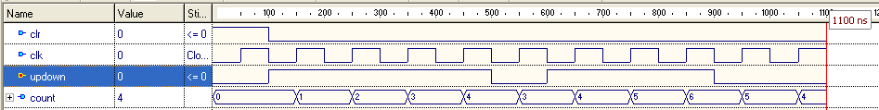

HARDWARE: COMPARATOR

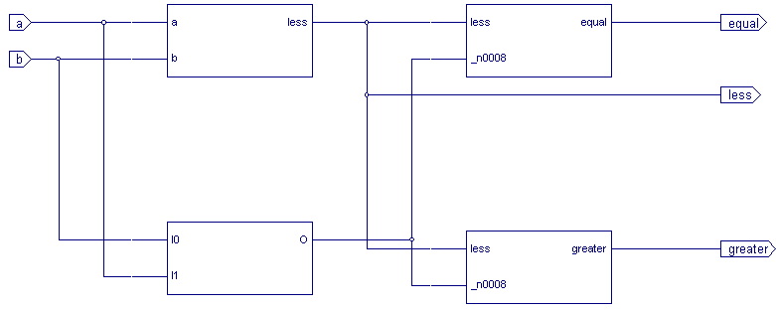

HARDWARE: DECODER

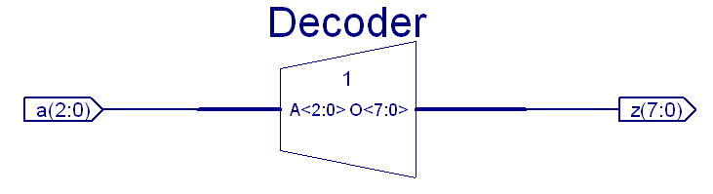

HARDWARE: FLIP FLOP

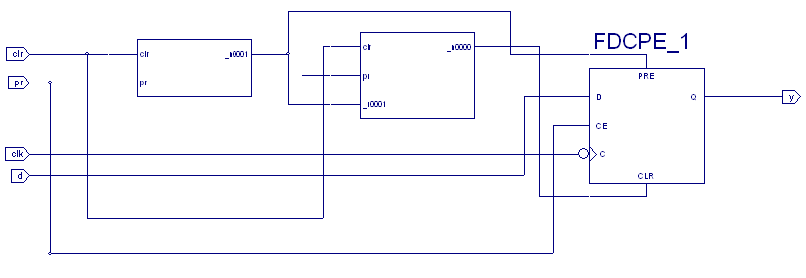

HARDWARE: DEMULTIPLEXER

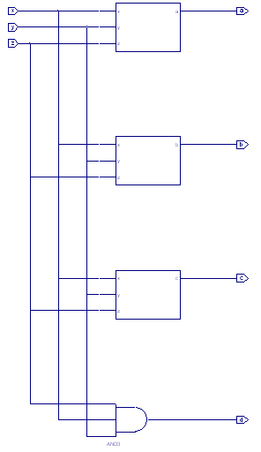

HARDWARE: COUNTER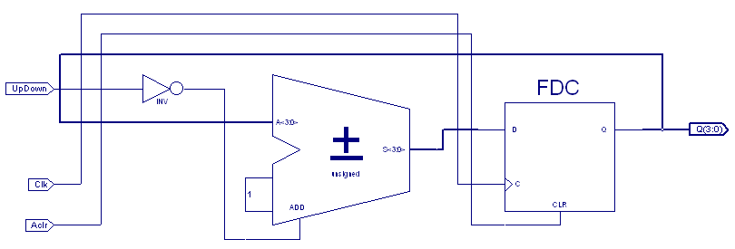

HARDWARE: ENCODER

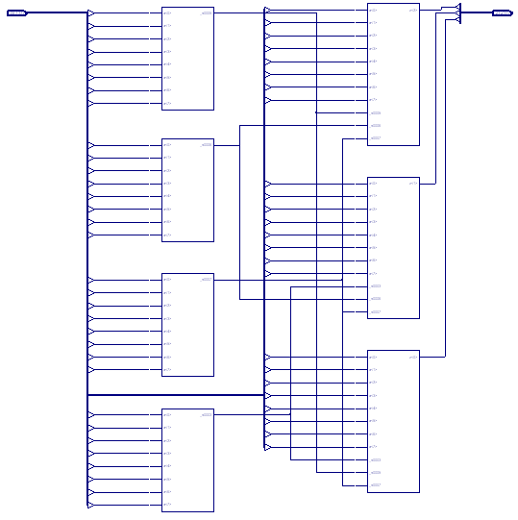

HARDWARE: FULL ADDER

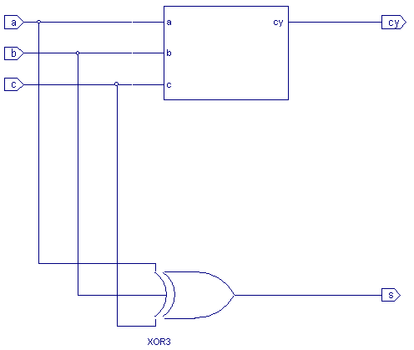

HARDWARE: HALF ADDER

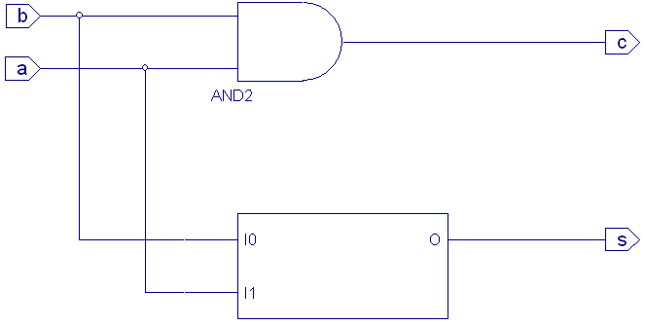

HARDWARE: MULTIPLEXER

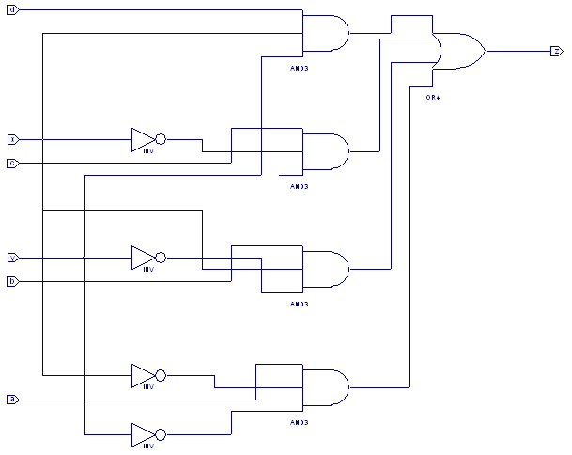

HARDWARE: SHIFT REGISTER

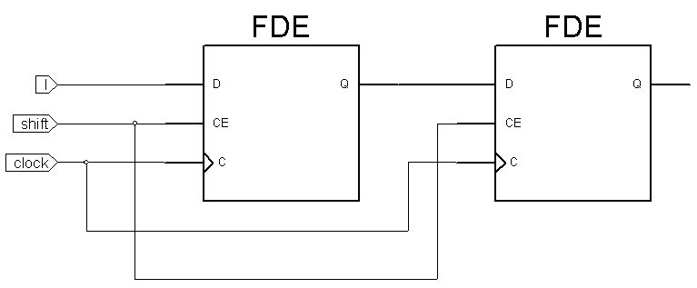

HARDWARE: CODE CONVERTER

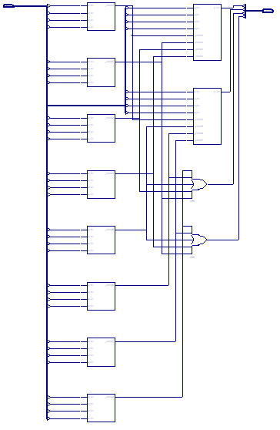

HARDWARE: REGISTER

